Wyatt Duberstein

SE 317

06-03-2022

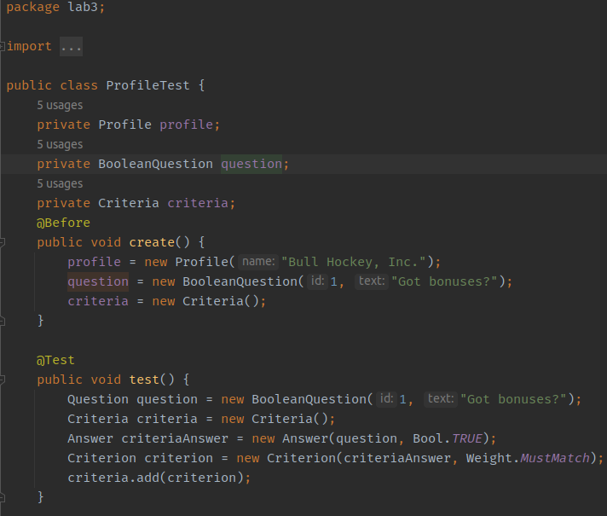

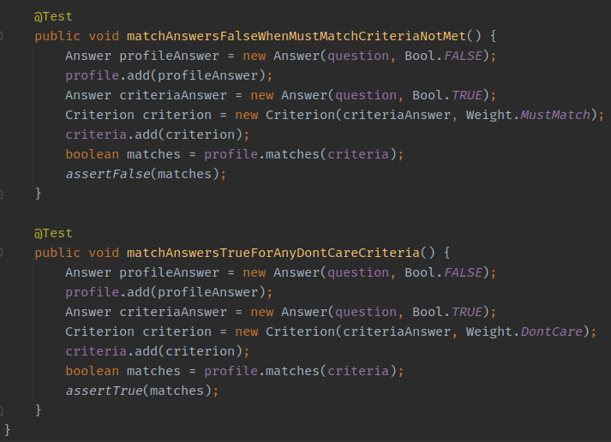

**Question 1:**

If the matchAnswersTrueForAnyDontCareCriteria is true, then it means that the answer, profile and criteriaAnswer are the same for both tests, except the criterion is set to Weight.DontCare rather than MustWatch, as we are testing the difference between the two. We then assert that the profile does not match the criteria given. If we then run the next test, it sets everything up the same except the criterion is set to Weight.MustWatch. Then, when we add the criterion to the existing criterion that has the DontCare weight from before, and assert that it now does match the criterion of the profile. Both tests pass.

**Question 2:**

Because the only variable that is affected by both tests is the criteria, I simply inlined the criteria variable and deleted the private class variable so that it would create a new variable every time the test is ran rather than using the same variable from the previous test. The results can be seen in the screenshot below. Both tests passed.

